**PIZZA SALES SQL QUERIES**

A.KPI’S

1. Total Reveue:-

SELECT SUM(total_price) AS Total_Revenue

FROM pizza_sales;

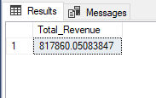

2. Average Order Value:-

SELECT SUM(total_price) / COUNT( DISTINCT order_id) AS Avg_Order_Value

FROM pizza_sales;

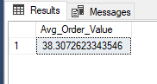

3. Total Pizza Sold:-

SELECT SUM(quantity) AS Total_Pizza_Sold

From pizza_sales;

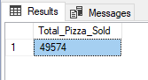

3. Total Orders:-

SELECT COUNT( DISTINCT order_id) AS Total_Orders

FROM pizza_sales;

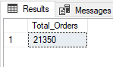

4. Average Pizza per Order:-

SELECT CAST(CAST(SUM(quantity) AS decimal(10,2))/

CAST(COUNT( DISTINCT order_id) AS decimal(10,2)) AS DECIMAL(10,2)) AS Avrage_Pizza_Orders

FROM pizza_sales;

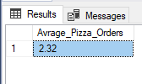

B.Daily Trend For Total Order:-

SELECT DATENAME(DW , order_date) AS order_day ,

COUNT(DISTINCT order_id) AS Total_orders

FROM pizza_sales

GROUP BY DATENAME(DW ,order_date);

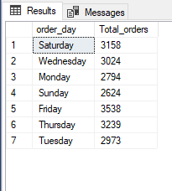

C.Monthly Trend For Total Order:-

SELECT DATENAME(MONTH , order_date) AS Month_Name ,

COUNT(DISTINCT order_id) AS Total_orders

FROM pizza_sales

GROUP BY DATENAME(MONTH ,order_date);

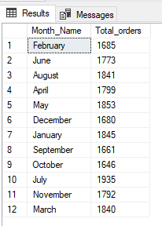

D.Percentage of Sales by Pizza Category:-

SELECT pizza_category ,

SUM(total_price)*100/

(SELECT SUM(total_price) FROM pizza_sales)

AS PCT

FROM pizza_sales

GROUP BY pizza_category;

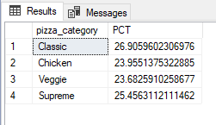

E.Percentage of Sales by Pizza Size:-

SELECT pizza_size ,

SUM(total_price)*100/

(SELECT SUM(total_price) FROM pizza_sales)

AS PCT

FROM pizza_sales

GROUP BY pizza_size;

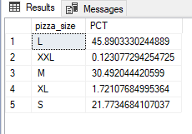

F.Total Pizza Sold by Pizza Category:-

SELECT pizza_category ,

CAST(SUM(total_price) AS decimal(10,2)) AS Total_Sales

FROM pizza_sales

GROUP BY pizza_category;

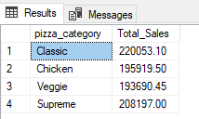

G.Top 5 Pizza by Revenue:-

SELECT TOP 5 pizza_name,

SUM(total_price) AS Total_Revanue

FROM pizza_sales

GROUP BY pizza_name

ORDER BY Total_Revanue DESC;

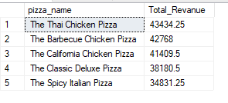

H.Bottom 5 Pizza by Revenue:-

SELECT TOP 5 pizza_name,

SUM(total_price) AS Total_Revanue

FROM pizza_sales

GROUP BY pizza_name

ORDER BY Total_Revanue ASC;

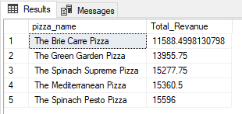

Note:- If you want to apply the pizza_category or pizza_size filters to the above queries you can use WHERE lause.